Voice Training Manual

This documents describes the steps and the requirements for voice training a system.

SOP version : 2.0

SOP date: 20/3/2018

# 1.Scope:

* This document covers all the necessary steps for training the voice recognition modules.
* This process is for training of only predefined audio commands.

# 2. Notes:

1. Opening a default terminal: Ctrl+Alt+T
2. Opening a terminal in the said folder: Right click inside the folder and select open in terminal.
3. Opening the file explorer: Ctrl+ Alt+F
4. Application folder: GUI-Voice (located inside folder Brabo on the desktop)
5. If you want to train for some other commands, please refer to

<https://cmusphinx.github.io/wiki/tutorialadapt/> . Also, make corresponding changes in **VoiDecoder.py** in the application folder.

1. Taking back-ups before editing any of the scripts is highly recommended.
2. This script is designed to train the voice recognition module with a single person.(If training is to be done with the input from multiple person refer to the cmusphinx official documentation <https://cmusphinx.github.io/wiki/> )

# 3. Equipment Pre-Checks

1. Ensure that the headset is attached properly to the system.
2. Set the volume for the microphone input to about 50% in the top right corner of the screen.
3. Make sure that the room is relatively noise free.

# 4. Procedure:

### Step 1:

Open Folder “Brabo” located on the desktop and go inside folder named “Voice Training” **.**

### Step 2:

Open a terminal in the current folder. And type the following command **./train** and press the enter key.

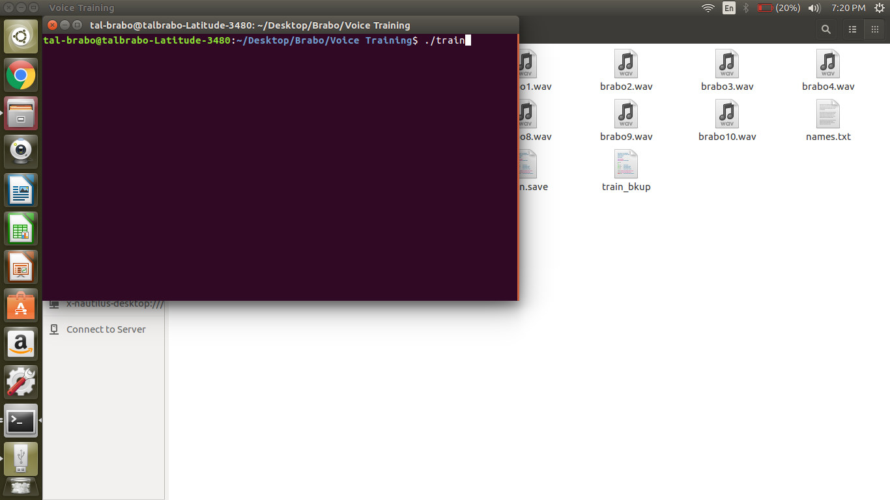

### Step 3:

A bash script starts executing with-in the terminal.

### Step 4:

Press **Enter** key to start/stop recording files. The audio **commands** to be recorded are given below. Ensure that the **order** in which the files are recorded remains the same as **given below**. Each command will be recorded in separate audio files.

1. Pick
2. Piece
3. Red
4. Green
5. Blue
6. Yellow
7. Pick red piece.
8. Pick green piece.
9. Pick blue piece.
10. Pick yellow piece.

### Step 5:

Press the **Enter** key and record the voice command. Once done press the **Enter** key to end recording.

### Step 6:

Once all files are recorded, system will play all recorded files in the same order as above. The script will then ask if the user wants to re-record any particular file. Type in Y or N for yes or no respectively and press enter.

### Step 7:

The script will then ask the user to enter the file number to be re-recorded. Enter the file number and record the corresponding voice command again. Continue this until all the commands have been recorded properly and once they are done, enter Y when asked if you want to “Execute” and press enter.

### Step 8:

The remainder of the script will execute and exit by itself once it is done. This will make changes in the voice module.

**NOTE:** If the voice training does not make any changes in the voice module, use the backup from the m4 folder in **Brabo/Gui_Voice/Scripts/resources/m4**.To do this copy the contents of this folder and paste them in the **Brabo/Gui_Voice/Scripts/resources/m6** folder.